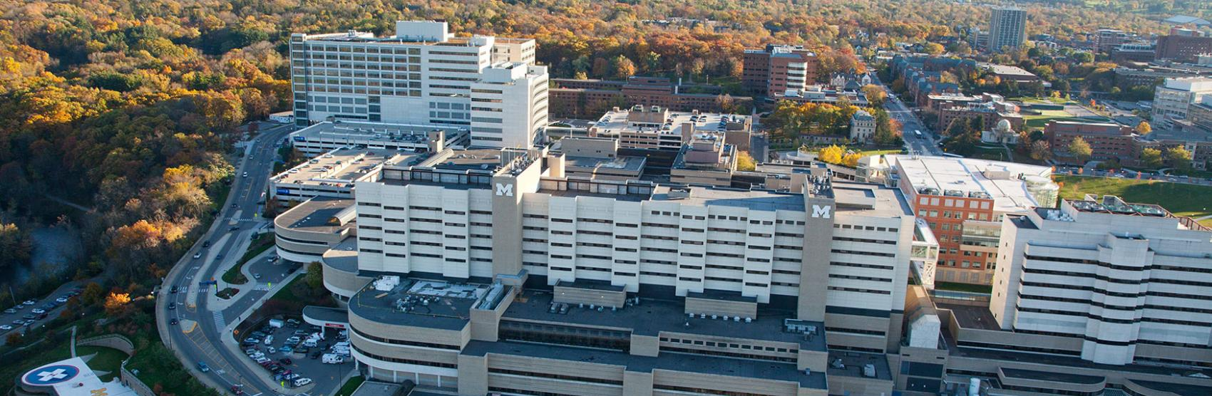

University of Michigan Health PGY2 Oncology Residency Program

Our program is designed to provide residents with a diverse set of experiences in hematology/oncology, while allowing collaboration with top experts at an NCI-designated Comprehensive Cancer Center. The program will challenge residents to develop high-level clinical and literature evaluation skills through a wide variety of inpatient and outpatient experiences. The strong affiliation with the University of Michigan College of Pharmacy allows residents to hone educational skills through didactic lectures, round table discussions, and precepting of fellows, residents, students. Upon completion of the program, residents will be among the leaders and best in hematology/oncology practice, poised to secure a specialized pharmacist position in hematology/oncology.

- Design & completion of a research project
- Completion of a writing project (review or secondary research project) suitable for publication
- Major topic presentations to heme/onc preceptor group every other month (5x/year)
- Service on professional committees (2 institutional and optional local/regional/national)
- National meetings: Vizient/Midyear Clinical Meeting, HOPA, Residency Trip
- Participation in Resident Wellness Activities
- Adjunct Clinical Instructor appointment
  - Teaching 1 semester at the College of Pharmacy and precepting APPE/IPPE students
  - ACPE Accredited CE to department
  - ONS Nursing Chemotherapy Lecture

Required:
- Orientation (July)
- Adult Inpatient Hematology
- Inpatient Bone Marrow Transplant
- Pediatric Hematology/Oncology
- Ambulatory Oncology GI/GU/Lung (Blue)
- Ambulatory Oncology GYO/Melanoma/Breast (Gold)
- Oncology Administration (2 weeks)
- Research Pharmacy (2-weeks)
- Longitudinal Clinic (1 semester)
  - Disease-based clinics (e.g., lung cancer)
Optional (see below)
- 14+ Available Clinics
- 10+ Inpatient Services
- Teaching/Academia
Rotation Experiences
Other Core Experiences

- Requires graduation from ASHP-Accredited or ASHP-candidate status PGY1 Pharmacy program & Michigan licensure within 60-days of program start
- Competitive salaries & medical benefit coverage
- 15 vacation/sick/interview days
- Program Director: Madeleine Ochs, PharmD, BCOP
Other Key Information
Operational Responsibilities

- Cancer Center Infusion Staffing (approx. one weekend per month; Fri evening, Saturday day)
- Work 2 Holiday Blocks (1 major, 1 minor)

Why Choose University of Michigan Health?
Being part of something greater, of serving a larger mission of discovery and care — that's the heart of what drives people to work at Michigan. In some way, great or small, every person here helps to advance this world-class institution. It adds a purpose to your profession. Train at the University of Michigan and become a victor for the greater good.
 | Longitudinal Clinic Rotations (4 hours per week; 5 months) – 1 longitudinal clinic per year
 | Rotation | Preceptor(s) | Required or Elective
 | Lymphoma Clinic | Iman Ahmed, PharmD, BCOP | One required for longitudinal experience
 | Multiple Myeloma Clinic | Iman Ahmed, PharmD, BCOP | One required for longitudinal experience
 | Leukemia Clinic | Pooja Kumar, PharmD, BCOP | One required for longitudinal experience
 | Bone Marrow Transplant Clinic | David Frame, PharmD  Tate Feeney, PharmD, BCOP | One required for longitudinal experience
Gold Clinics | Gynecologic Oncology Clinic | Catherine Christen, PharmD | One required for longitudinal experience
Gold Clinics | Melanoma Clinic | Shawna Kraft, PharmD, BCOP | One required for longitudinal experience
Gold Clinics | Breast Cancer Clinic | Shawna Kraft, PharmD, BCOP | One required for longitudinal experience
Blue Clinics | Genitourinary Cancer Clinic | Shawna Kraft, PharmD, BCOP | One required for longitudinal experience
Blue Clinics | Head/Neck Cancer Clinic | Rachel McDevitt, PharmD, BCOP  Allison Schepers, PharmD, BCOP | One required for longitudinal experience
Blue Clinics | Gastrointestinal Cancer Clinic |  | One required for longitudinal experience
Blue Clinics | Sarcoma Clinic |  | One required for longitudinal experience
Blue Clinics | Lung Cancer Clinic |  | One required for longitudinal experience
 | Oral Chemotherapy Clinic | Anna Kempke, PharmD, BCOP, BCPS | One required for longitudinal experience

Block Rotations (unless specified, all required rotations are 4 weeks; electives may be 2-4 weeks)
Rotation | Preceptor(s) | Required or Elective
Orientation | Allison Schepers, PharmD, BCOP | Required (July)
Adult Inpatient Hematology (MHE) | Bernard Marini, PharmD, BCOP  Anthony Perissinotti, PharmD, BCOP  Martina Fraga, PharmD, BCOP | Required
Inpatient Hematology (MHP) |  | Elective
Inpatient Oncology (MON) | Alanna Lehman, PharmD, BCOP | Elective
Inpatient Bone Marrow Transplant | Denise Markstrom, PharmD  Gianni Scappaticci, PharmD, BCOP | Required
Pediatric Hematology/Oncology | Julia Brown, PharmD  Madeleine King, PharmD, BCOP | Required
Oncology Administration | Lydia Benitez, PharmD, BCOP  Emily Mackler, PharmD, BCOP  Prabha Vogel, PharmD, BCOP, BCPS | Required (2 weeks plus longitudinal leadership series)
Ambulatory Oncology GI/GU/Lung (Blue) | Rachel McDevitt, PharmD, BCOP  Shawna Kraft, PharmD, BCOP  Allison Schepers, PharmD, BCOP | Required
Ambulatory Oncology GYO/Melanoma/Breast (Gold) | Catherine Christen, PharmD  Shawna Kraft, PharmD, BCOP | Required
Ambulatory Hematology (Lymphoma/  Myeloma/Leukemia) | Iman Ahmed, PharmD, BCOP  Pooja Kumar, PharmD, BCOP | Elective
Ambulatory Bone Marrow Transplant | Tate Feeney, PharmD, BCOP  David Frame, PharmD | Elective
Hematology Consult Service | Madeleine Ochs, PharmD, BCOP | Elective
Infectious Diseases | Samuel Aitken, PharmD, MPH, BCIDP  Greg Eschenauer, PharmD, BCPS, BCIDP  Jerod Nagel, PharmD, BCPS, BCIDP | Elective§  §ID topics will also be covered in IP Adult Hematology and IP BMT rotations
Medical ICU | Michael Kenes, BCCCP, BCPS  Megan Ingebrigtson, BCCCP | Elective
Teaching/Academia | Shawna Kraft, PharmD, BCOP | Elective (4 weeks)
Advanced Ambulatory Care, Advanced Inpatient, and Advanced IP/OP Hybrid | Any preceptor | Elective
*The following ambulatory oncology clinics are required, either longitudinally or in the month-long blocks: breast cancer, colorectal/pancreatic cancer, melanoma, lung cancer, ovarian cancer, prostate cancer

